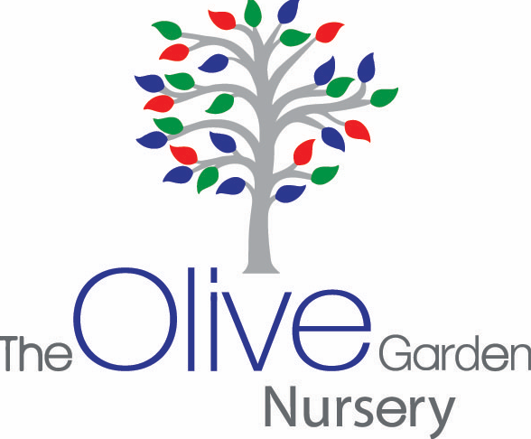
Intake of

Waiting list form for 2 year old

Name of Child: …………………………………………

Date of Birth: ……………………………………

Address: ……………………………………………………………………………………………………………..

Contact no 1 ………………………………………………………………………………………..

Contact no 2…………………………………………………………………………………………

We offer 15 hours, please specify which session you would prefer

5 Mornings □ OR 5 Afternoons □ OR Full time □

Please specify which funding you have applied or will be applying for as this will be needed once a place is offered:

Bolton Council □  As a family you earn £16,100 or less, either through work or benefits, please use the following link:  https://ems.bolton.gov.uk/CitizenPortal_LIVE/en | Childcare Choices □  If BOTH parents are working, please use the following link to apply for the free 15 hours.  https://www.childcarechoices.gov.uk/

Is the parent a committee member of Ar-Rahman Masjid? …………………………………………..

If yes, please state name of member

………………………………………………………………………………………………………………

Does the child have additional needs? …………………………………………………………………

Is the child a “looked after child” by Local Authority? ……………………………

Date:...................................

NOTE: The cut off point for admissions for the following September will be before the February half term. If your child does not get a 2yr old place, we will automatically move your application to our 3yr old waiting list.

